## **Experiment No.1**

**Aim: -**

### Write a program to show the basic input & output function

**Source Code: -**

1 /*

2 *Basic Input Output

3 */

4 #include "iostream"

5

6 **using namespace std**;

7

8 **int** main()

9 {

10 **int** num;

11 **cout**<<"Hello to the world of C++ Programming";

12 **cout**<<"\nEnter Numeric Value :";

13 **cin**>> num;

14 **cout**<<"\nYou Enter :"<<num<<**endl**;

15 system("pause");//To stop the console from disappearing

16 **return** 0;

17 }

**Output: -**

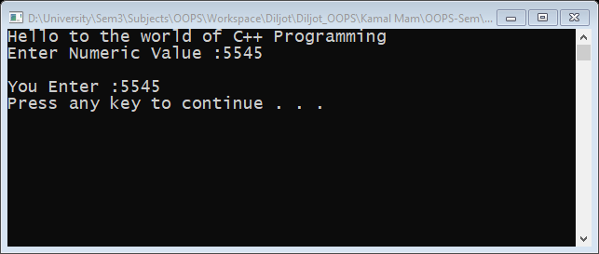

## **Experiment No.2**

**Aim: -**

### Write a program to find greatest number among three (nested If)

**Source Code: -**

1 /*

2 *Largest Using Nested if else

3 */

4 #include "iostream"

5 **using namespace std**;

6

7 **int** main()

8 {

9 **float** n1,n2,n3;

10 **cout**<<"LARGEST AMONG THREE (NESTED IF ELSE) \nEnter three numbers: ";

11 **cin**>>n1>>n2>>n3;

12 **if**(n1>=n2 && n1>=n3)

13 {

14 **cout**<<"Largest number: "<<n1<<**endl**;

15 }

16 **else if**(n2>=n1 && n2>=n3)

17 {

18 **cout**<<"Largest number: "<<n2<<**endl**;

19 }

20 **else**

21 {

22 **cout**<<"Largest number: "<<n3<<**endl**;

23 }

24 system("pause");

25 **return** 0;

26

**Output: -**

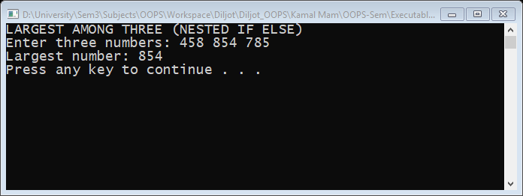

## **Experiment No.3**

**Aim: -**

### Write a program to find if given number is even or odd

**Source Code: -**

1 /*

2 *To find the no. is even or odd

3 */

4 #include "iostream"

5

6 **using namespace std**;

7

8 **int** main()

9 {

10 **int** number;

11 **cout**<<"\t\t\tEVEN ODD"<<"\nEnter the value:- ";

12 **cin**>>number;

13 **if**((number%2)==0)

14 {

15 **cout**<<number<<" is Even\n";

16 }

17 **else**

18 {

19 **cout**<<number<<" is odd\n";

20 }

21 system("pause");

22 **return** 0;

23

**Output: -**

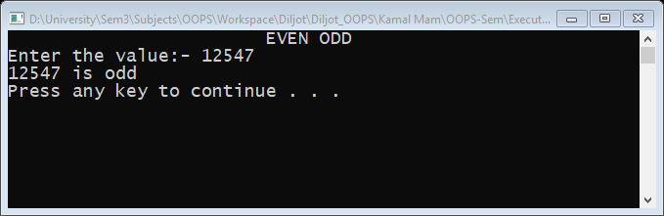

## **Experiment No.4**

**Aim: -**

### Write a program of days of week using Switch Statement

**Source Code: -**

1 /*

2 *using switch

3 * - Days of week

4 */

5 #include "iostream"

6

7 **using namespace std**;

8

9

10

11 **int** main()

12 {

13 **int** num;

14 **cout**<<"\t\t\tDAYS OF WEEK\n";

15 **cout**<<"Enter number :- ";

16 ab:

17 **cin**>>num;

18

19 **switch** (num)

20 {

21 **case** 1: **cout**<<"\n Monday \n";

22 **break**;

23 **case** 2: **cout**<<"\n Tuesday \n";

24 **break**;

25 **case** 3: **cout**<<"\n Wednesday \n";

26 **break**;

27 **case** 4: **cout**<<"\n Thursday \n";

28 **break**;

29 **case** 5: **cout**<<"\n Friday \n";

30 **break**;

31 **case** 6: **cout**<<"\n Saturday \n";

32 **break**;

33 **case** 7: **cout**<<"\n Sunday \n";

34 **break**;

35 **default**:**cout**<<"WORNG CHOICE\nEnter choice again:- ";

36 **goto** ab;

37 **break**;

38 }

39 system("pause");

40 **return** 0;

41 }

42

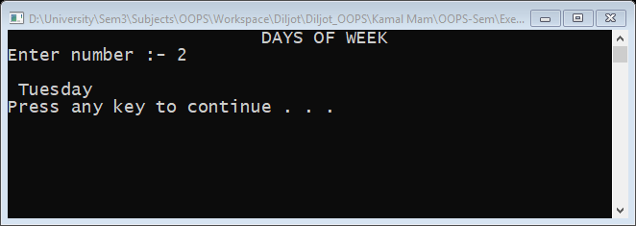**Output: -**

## **Experiment No.5**

**Aim: -**

### Write a program to make a simple calculator using switch statement

**Source Code: -**

1 /*

2 *To making Calculator using switch.

3 */

4 #include "iostream"

5 #include "conio.h"

6

7 **using namespace std**;

8

9 **int** main()

10 {

11 **int** num1,num2;

12 **char** ch,chx;

13 **cout**<<"\t\tCalculator\n";

14 **cout**<<"\t1.Addition +\n\t2.Subtraction (-)\n\t3.Division (/)\n\t4.Multiplication (*)";

15 **cout**<<"\nEnter in (oprand operator oprand)";

16 restart:

17 **cout**<<"\nEnter :-";

18 **cin**>>num1>>ch>>num2;

19 **switch**(ch)

20 {

21 **case** '+':**cout**<<"\nResult := "<<num1+num2<<**endl**;

22 **break**;

23 **case** '-':**cout**<<"\nResult := "<<num1-num2<<**endl**;

24 **break**;

25 **case** '/':**cout**<<"\nResult := "<<num1/num2<<**endl**;

26 **break**;

27 **case** '*':**cout**<<"\nResult := "<<num1*num2<<**endl**;

28 **break**;

29 **default**:**cout**<<"\nWrong Inputs";

30 **break**;

31 }

32 **cout**<<"Another Calculation (Y/N)";

33 chx=getch();

34 **if**(chx=='y'||chx=='Y')

35 {

36 **goto** restart;

37 }

38 system("pause");

39 **return** 0;

40 }

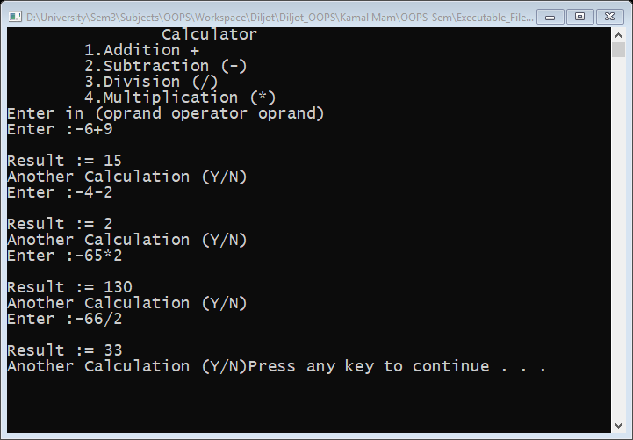**Output: -**

## **Experiment No.6**

**Aim: -**

### Write a program to find if given number is prime or not using for Statement

**Source Code: -**

1 /*

2 *Prime Number

3 */

4 #include ”iostream”

5 **using namespace std**;

6

7 **int** main()

8 {

9 **long long unsigned int** n, i;

10 **bool** Prime = **true**;

11 **cout**<<"CHECK WHEATHER A NUMBER IS PRIME OR NOT\n";

12 **cout** << "Enter a positive integer: ";

13 **cin** >> n;

14

15 **for**(i = 2; i <= n / 2; ++i)

16 {

17 **if**(n % i == 0)

18 {

19 Prime = **false**;

20 **break**;

21 }

22 }

23 **if** (Prime)

24 **cout** << "This is a prime number\n";

25 **else**

26 **cout** << "This is not a prime number\n";

27 system("pause");

28 **return** 0;

**Output: -**

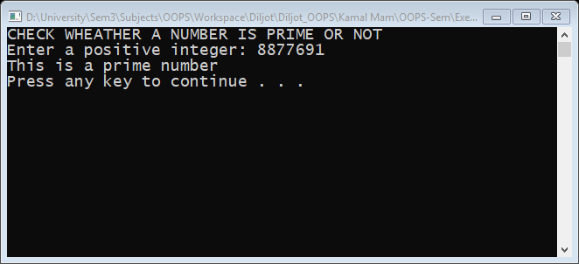

## **Experiment No.7**

**Aim: -**

### Write a program to print Fibonacci series using loop

**Source Code: -**

1 /*

2 *Fibonacci Series Using While Loop

3 */

4 #include "iostream"

5

6 **using namespace std**;

7

8 **int** main()

9 {

10 **int** i,n,next_term=1,a=0;

11 **cout**<<"FIBONACCI SERIES USING WHILE LOOP";

12 **cout**<<"\nEnter the Number of terms :-";

13 **cin**>>n;

14 **cout**<<"Fibonnacci Series :- ";

15

16 **while**(n>0)

17 {

18 **cout**<<a<<" ";

19 i=a+next_term ;

20 next_term=a;

21 a=i;

22 n--;

23 }

24 **cout**<<**endl**;

25 system("pause");

26

**Output: -**

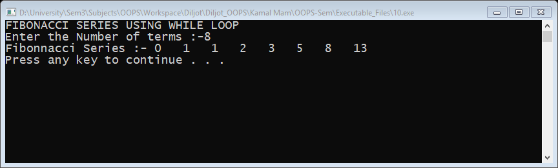

## **Experiment No.8**

**Aim: -**

### Write a program to calculate the sum of digits of a number using loops

**Source Code: -**

1 /*

2 *Sum of Digits using while

3 */

4 #include "iostream"

5 #include "conio.h"

6

7 **using namespace std**;

8

9 **int** main()

10 {

11 **int** n,t=1,sum=0,remainder=0;;

12 **cout**<<"\t\tSUM OF DIGITS\n"<<"Enter a Number = ";

13 **cin**>>n;

14 t = n;

15 **while** (t !=0)

16 {

17 remainder = t % 10;

18 sum = sum + remainder;

19 t = t / 10;

20 }

21 **cout**<<"Sum of digits of "<<n<<" = "<<sum<<"\n";

22 system("pause");

23 **return** 0;

24 }

**Output: -**

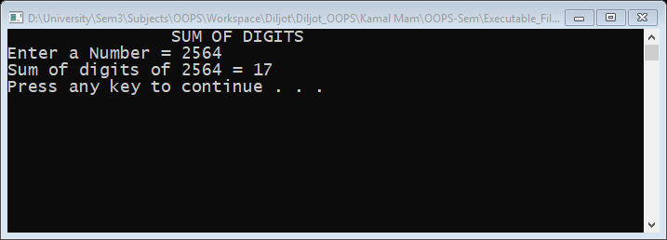

## **Experiment No.9**

**Aim: -**

### Write a program to print table of any number

**Source Code: -**

1 /*

2 *Table Of Given number

3 */

4 #include "iostream"

5 #include "conio.h"

6

7 **using namespace std**;

8

9 **int** main()

10 {

11 **int** Max,n;

12 **cout**<< "\t\tTABLE OF GIVEN NUMBER\n";

13 **cout**<< "Enter Table & Max Limit = ";

14 **cin**>>n>>Max;

15 **for** (**int** i=0;i<=Max;i++)

16 {

17 **cout**<<n<<"*"<<i<<"="<<n*i<<"\n";

18 }

19 getch();

20 **return** 0;

21 }

**Output: -**

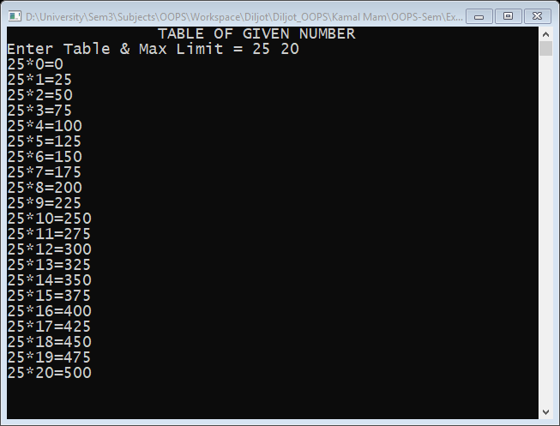

## **Experiment No.10**

**Aim: -**

### Write a program to convert Given Number into binary number

**Source Code: -**

1 /*

2 *Convert Decimal To Binary

3 */

4 #include "iostream"

5 #define SIZE 500

6

7 **using namespace std**;

8

9 **int** main()

10 {

11 **int** a[SIZE], n, i,j;

12 **cout**<<"CONVERT DECIMAL TO BINARYS\nEnter the number: ";

13 **cin**>>n;

14 **for**(i=0; n>0; i++)

15 {

16 a[i]=n%2;

17 n= n/2;

18 }

19 **int** b[i];

20 **cout**<<"\nBinary of the given number= ";

21 **for**(i=i-1,j=0 ;i>=0 ;i--,j++)

22 {

23 b[j]=a[i];

24 }

25 **for**(i=0;i<(**sizeof**(b)/**sizeof**(b[0]));i++)

26 {

27 **cout**<<b[i];

28 }

29 **cout**<<"\n";

30 system("pause");

31 }

**Output: -**

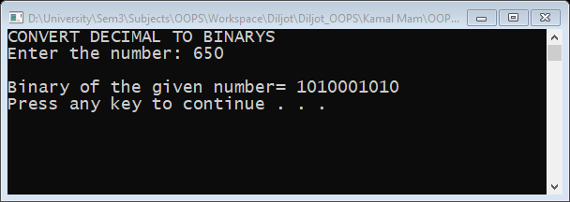

## **Experiment No.11**

**Aim: -**

### Write a program to print single pyramid (*) using loop

**Source Code: -**

1 /*

2 *Half Pyramid (*).

3 */

4 #include "iostream"

5 **using namespace std**;

6

7 **int** main()

8 {

9 **int** rows;

10

11 **cout**<<"HALF PYRAMID PATTERN\nEnter number of rows: ";

12 **cin**>>rows;

13

14 **for**(**int** i=1;i<=rows;++i)

15 {

16 **for**(**int** j=1;j<=i;++j)

17 {

18 **cout**<<"* ";

19 }

20 **cout**<<"\n";

21 }

22 system("pause");

23 **return** 0;

24 }

**Output: -**

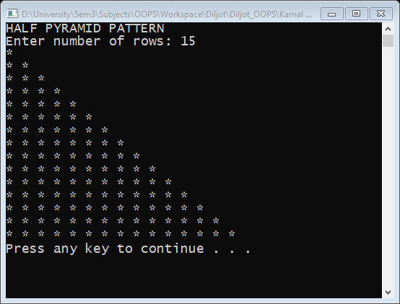

## **Experiment No.12**

**Aim: -**

### Write a program to print single pyramid (using digits) using loop

**Source Code: -**

1 /*

2 *half pyramid using digits

3 */

4 #include "iostream"

5 **using namespace std**;

6

7 **int** main()

8 {

9 **int** rows;

10 **cout**<<"DIGITS HALF PYRAMID\nEnter number of rows: ";

11 **cin**>>rows;

12 **for**(**int** i=1;i<=rows;++i)

13 {

14 **for**(**int** j=1;j<=i;++j)

15 {

16 **cout**<<j<<" ";

17 }

18 **cout**<<"\n";

19 }

20 system("pause");

21 **return** 0;

22

**Output: -**

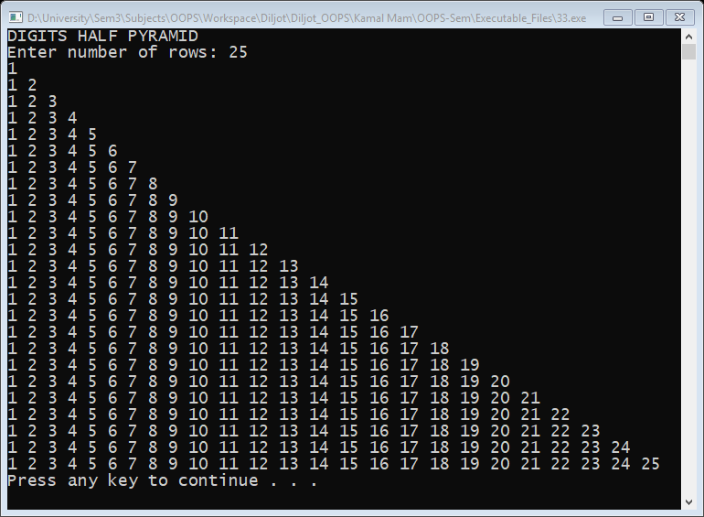

## **Experiment No.13**

**Aim: -**

### Write a program to print double pyramid (*) using loop

**Source Code: -**

1 /*

2 *full pyramid

3 */

4 #include "iostream"

5 **using namespace std**;

6

7 **int** main()

8 {

9 **int** space, rows;

10

11 **cout**<<"Enter number of rows: ";

12 **cin**>>rows;

13

14 **for**(**int** i=1,k=0;i<=rows;++i,k=0)

15 {

16 **for**(space=1;space<=rows-i;++space)

17 {

18 **cout** <<" ";

19 }

20

21 **while**(k != 2*i-1)

22 {

23 **cout** << "* ";

24 ++k;

25 }

26 **cout** << **endl**;

27 }

28 system("pause");

29 **return** 0;

30

**Output: -**

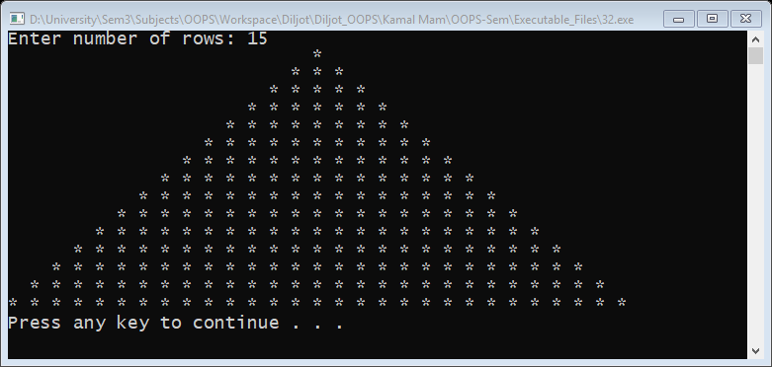

## **Experiment No.14**

**Aim: -**

### Write a program to find cube of first 10 integers using inline function

**Source Code: -**

1 /*

2 *Calculate cube of integer(using inline function)

3 */

4 #include "iostream"

5

6 **using namespace std**;

7

8 **void inline** cube(**int** n)

9 {

10 **int** rst;

11 rst=n*n*n;

12 **cout**<<"The Cube of "<<n<<" is "<< rst<<**endl**;

13 }

14

15 **int** main()

16 {

17 **int** number;

18 **cout**<<"CUBE TILL GIVEN NUMBER\n Enter the Number :-";

19 **cin**>>number;

20 **for**(**int** i =1;i<=number;i++)

21 {

22 cube(i);

23 }

24 system("pause");

25 **return** 0;

26 }

**Output: -**

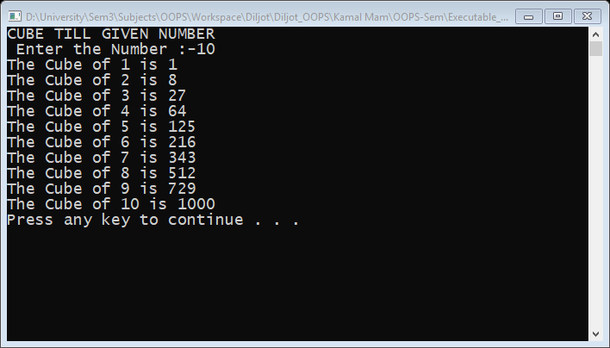

## **Experiment No.15**

**Aim: -**

### Write a program to find largest and smallest elements among the array along with sum and average of element

**Source Code: -**

1 /*

2 *Write a program to find largest and smallest elements among the array along with sum and average of element

3 */

4 #include "iostream"

5

6 **using namespace std**;

7

8 **int** main(**int** argc, **char const** *argv[])

9 {

10 **int** j=0,SIZE,sum=0,avg,largest,smallest;

11 **cout**<<"SUM, AVERAGE, LARGEST AND SMALLEST AMONG ARRAY ELEMENTS";

12 **cout**<<"\nEnter the Size of Array :";

13 **cin**>>SIZE;

14 **cout**<<"\nEnter the Arrary Elements :";

15 **int array**[SIZE],**copy**[SIZE];

16 **for**(**int** i=0;i<SIZE;i++)

17 {

18 **cin**>>**array**[i];

19 **copy**[i]=**array**[i];

20 }

21 largest=smallest=**copy**[0];

22 **while**(j < SIZE)

23 {

24 **if**(largest<**copy**[j])

25 {

26 largest=**copy**[j];

27 }

28 **if**(smallest>**copy**[j])

29 {

30 smallest=**copy**[j];

31 }

32 sum += **copy**[j];

33 j++;

34 }

35 avg=sum/SIZE;

36 **cout**<<"Largest Element is "<<largest<<**endl**;

37 **cout**<<"Smallest Element is "<<smallest<<**endl**;

38 **cout**<<"Sum of Array Elements is "<<sum<<**endl**;

39 **cout**<<"Average Of array elements is "<<avg<<**endl**;

40 system("pause");

41 **return** 0;

42 }

**Output: -**

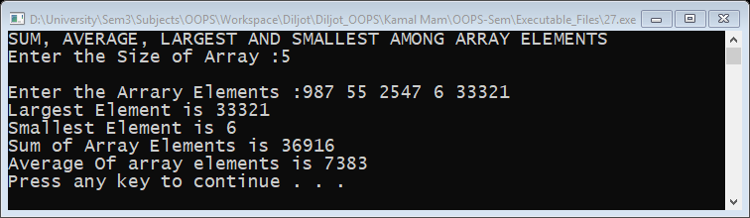

## **Experiment No.16**

**Aim: -**

### Write a program to factorial of number using function

**Source Code: -**

1 /*

2 *Factorial of a number using functions.

3 */

4 #include "iostream"

5

6 **using namespace std**;

7

8 **int** Factorial(**int** n )

9 {

10 **if**(n > 1)

11 **return** n * Factorial(n - 1);

12 **else**

13 **return** 1;

14 }

15 **int** main()

16 {

17 **int** a;

18 **cout**<<"FACTORIAL USING RECURESIVE FUNCTIONS \n Enter a Number :- ";

19 **cin**>>a;

20 **cout**<<"\nFactorial of "<<a<<" is "<<Factorial(a)<<**endl**;

21 system("pause");

22 **return** 0;

23

**Output: -**

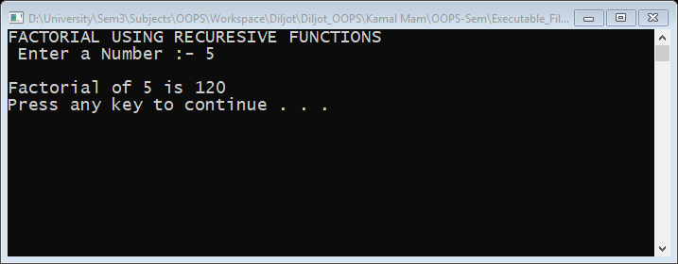

## **Experiment No.17**

**Aim: -**

### Write a program to find greatest and smallest among three number using function (argument passing)

**Source Code: -**

1 /*

2 * To find greatest among three integers and output the largest integer

3 */

4 #include "iostream"

5

6 **using namespace std**;

7

8 **int** greatest(**int** num1,**int** num2,**int** num3)

9 {

10 **int** MAX;

11 **if**((num1>num2)&&(num1>num3))

12 MAX=num1;

13 **else if**((num2>num1)&&(num2>num3))

14 MAX=num2;

15 **else**

16 MAX=num3;

17 **return** MAX;

18 }

19

20 **int** main()

21 {

22 **int** num1,num2,num3;

23 **cout**<<"\t\tGREATEST AMONG THREE NUMBERS\n";

24 **cout**<<"Enter three numbers Respectively (Each Seprated By Space)\n";

25 **cin**>>num1>>num2>>num3;

26 **cout**<<"Greatest of them is "<<greatest(num1,num2,num3)<<**endl**;

27 system("pause");

28 **return** 0;

29 }

**Output: -**

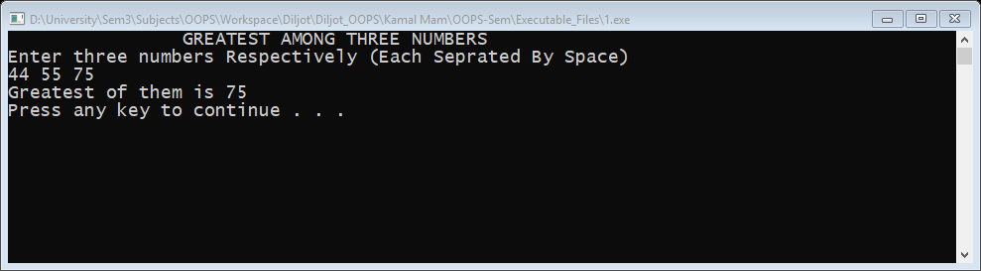

## **Experiment No.18**

**Aim: -**

### Write a program to find sum of first n odd or even numbers

**Source Code: -**

1 /*

2 *Sum of Even and Odd no.s from 1 to 100.

3 */

4 #include "iostream"

5

6 **using namespace std**;

7

8 **int** main()

9 {

10 **int** esum=0,osum=0,n,selector;

11 **cout**<<"SUM OF EVEN AND ODD NUMBER UPTO GIVEN NUMBER\n";

12 **cout**<<"Enter 0 - odd or 1 - even:-";

13 **cin**>>selector;

14 **cout**<<"Enter the end Number :- ";

15 **cin**>>n;

16 **for**(**int** i=1;i<n;i++)

17 {

18 **if** (i%2 ==0)

19 {

20 esum+=i;

21 }

22 **else**

23 {

24 osum+=i;

25 }

26 }

27 **if**(selector==1)

28 **cout**<<"\nSum of Even Numbers : - "<<esum<<**endl**;

29 **if**(selector==0)

30 **cout**<<"Sum of odd Numbers : - "<<osum<<**endl**;

31 system("pause");

32 **return** 0;

33

**Output: -**

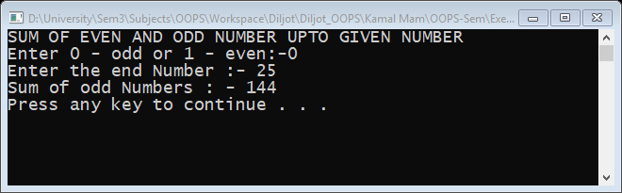

## **Experiment No.19**

**Aim: -**

### Write a program to swap the values by passing reference

**Source Code: -**

1 /*

2 *swap the values by passing reference

3 */

4 #include "iostream"

5

6 **using namespace std**;

7

8 **void** swapr(**int**\* x,**int**\* y)

9 {

10 **int** z=*x;

11 *x=*y;

12 *y=z;

13 **cout**<<"\nDuring\n";

14 **cout**<<"The value of a = "<<*x<<"\n";

15 **cout**<<"The value of b = "<<*y<<"\n";

16 }

17

18 **int** main()

19 {

20 **int** a,b;

21 **cout**<<"SWAP BY REFFRENCE\n\n";

22 **cout**<<"\nEnter Two Values = ";

23 **cin**>>a>>b;

24 **cout**<<"Before\n";

25 **cout**<<"The value of a = "<<a<<**endl**;

26 **cout**<<"The value of b = "<<b<<**endl**;

27 swapr(&a,&b);

28 **cout**<<"\nAfter\n";

29 **cout**<<"The value of a = "<<a<<**endl**;

30 **cout**<<"The value of b = "<<b<<**endl**;

31 system("pause");

32 **return** 0;

33 }

**Output: -**

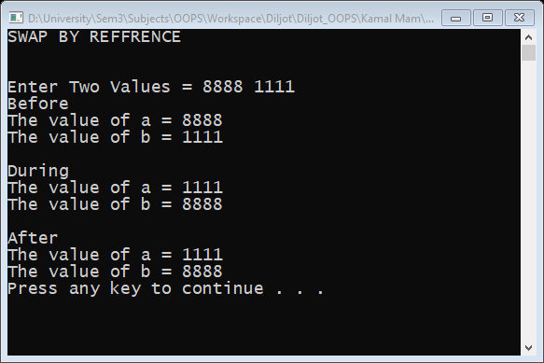

## **Experiment No.20**

**Aim: -**

### Write a program to swap the values by passing the actual value

**Source Code: -**

1 /*

2 *swap the values by passing value

3 */

4 #include "iostream"

5

6 **using namespace std**;

7

8 **void** swapv(**int** x,**int** y)

9 {

10 **int** z=x;

11 x=y;

12 y=z;

13 **cout**<<"\nDuring\n";

14 **cout**<<"The value of a = "<<x<<"\n";

15 **cout**<<"The value of b = "<<y<<"\n";

16 }

17

18 **int** main()

19 {

20 **int** a,b;

21 **cout**<<"SWAP BY VALUE\n\n";

22 **cout**<<"\nEnter Two Values = ";

23 **cin**>>a>>b;

24 **cout**<<"Before\n";

25 **cout**<<"The value of a = "<<a<<**endl**;

26 **cout**<<"The value of b = "<<b<<**endl**;

27 swapv(a,b);

28 **cout**<<"\nAfter\n";

29 **cout**<<"The value of a = "<<a<<**endl**;

30 **cout**<<"The value of b = "<<b<<**endl**;

31 //values of a & b will remain same before and after swap because

32 //the swap takes place in a duplicate memory not in actual variable

33 system("pause");

34 **return** 0;

35 }

**Output: -**

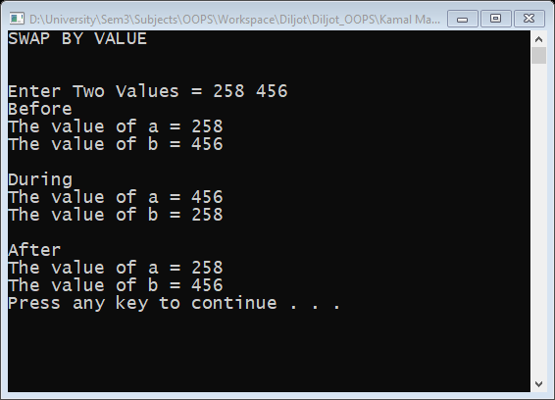

## **Experiment No.21**

**Aim: -**

### Write a program to implement a simple class

**Source Code: -**

1 /*

2 *implementation of class and object

3 */

4 #include "iostream"

5

6 **using namespace std**;

7

8 **class** person //new class is created

9 {

10 **string** name;//Member Variable

11 **int** age;//Member Variable

12

13 **public**:

14 **void** getData()//Member Function

15 {

16 **cout** <<"Enter The Name = ";

17 **cin**>>name;

18 **cout**<<"Enter Age = ";

19 **cin**>>age;

20 }

21 **void** display()//Member Function

22 {

23 **cout**<<"Name = "<<name<<"\nAge ="<<age<<**endl**;

24 }

25 } ;

26

27 **int** main()

28 {

29 person p;//object of class is created

30 p.getData();

31 **cout**<<"\n You Enterd \n";

32 p.display();

33 system("pause");

34 **return** 0;

35 }

**Output: -**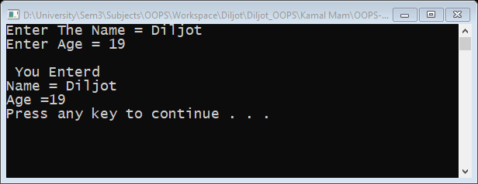

## **Experiment No.22**

**Aim: -**

### Write a program for nesting a member function within a member function

**Source Code: -**

1 /*

2 *Nesting Member function

3 */

4 #include<iostream>

5

6 **using namespace std**;

7

8 **class set**

9 {

10 **int** m,n;

11 **public**:

12 **void** input()

13 {

14 **cout**<<"Input values of m and n\n";

15 **cin**>>m>>n;

16 }

17 **int** largest()

18 {

19 **if**(m>=n)

20 **return** m;

21 **else**

22 **return** n;

23 }

24 **void** display()

25 {

26 **cout**<<"Largest value="<<largest()<<"\n";

27 }

28

29 };

30 **int** main()

31 {

32 **set** obj;

33 obj.input();

34 obj.display();

35 system("pause");

36 }

**Output: -**

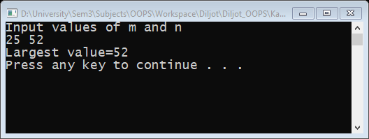

## **Experiment No.23**

**Aim: -**

### Write a program to implement static data members

**Source Code: -**

1 /*

2 *static data members

3 */

4 #include "iostream"

5

6 **using namespace std**;

7

8 **class** item

9 {

10 **static int count**;

11 **int** number;

12 **public**:

13 **void** getdata(**int** a)

14 {

15 number=a;

16 **count**++;

17 }

18 **void** getcount()

19 {

20 **cout**<<"count:";

21 **cout**<<**count**<<**endl**;

22 }

23 };

24 **int** item::**count**;

25 **int** main()

26 {

27 item a,b,c;

28 a.getcount();

29 b.getcount();

30 c.getcount();

31 a.getdata(100);

32 b.getdata(200);

33 c.getdata(300);

34 **cout**<<"After reading data"<<**endl**;

35 a.getcount();

36 b.getcount();

37 c.getcount();

38 system("pause");

39 }

**Output: -**

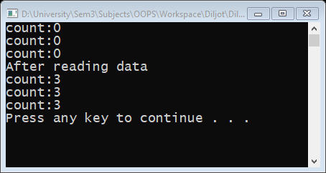

## **Experiment No.24**

**Aim: -**

### Write a program to implement static member functions

**Source Code: -**

1 /*

2 *static member functions

3 */

4 #include "iostream"

5

6 **using namespace std**;

7 **class** test

8 {

9 **int** code;

10 **static int count**;

11 **public**:

12 **void** setcode()

13 {

14 code=++**count**;

15 }

16 **void** showcode()

17 {

18 **cout**<<"object number:"<<code<<"\n";

19 }

20 **static void** showcount()

21 {

22 **cout**<<"count:"<<**count**<<"\n";

23 }

24 };

25 **int** test::**count**;

26 **int** main()

27 {

28 test t1,t2;

29 t1.setcode();

30 test::showcount();

31 t2.setcode();

32 test::showcount();

33 test t3;

34 t3.setcode();

35 test::showcount();

36 t1.showcode();

37 t2.showcode();

38 t3.showcode();

39 system("pause");

40 }

**Output: -**

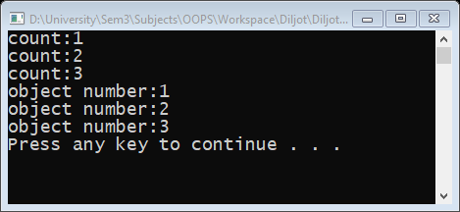

## **Experiment No.25**

**Aim: -**

### Write a program to make an array of objects

**Source Code: -**

**Output: -**

## **Experiment No.26**

**Aim: -**

### Write a program to implement friend functions

**Source Code: -**

**Output: -**

## **Experiment No.27**

**Aim: -**

### Write a program to make friend function of two classes.

**Source Code: -**

**Output: -**

## **Experiment No.28**

**Aim: -**

### Write a program to implement hierarchical inheritance

**Source Code: -**

**Output: -**

## **Experiment No.29**

**Aim: -**

### Write a program to use constructors with simple class

**Source Code: -**

**Output: -**

## **Experiment No.30**

**Aim: -**

### Write a program to implement an overloaded constructor

**Source Code: -**

**Output: -**

## **Experiment No.18**

**Aim: -**

### Write a program to make objects as arguments

**Source Code: -**

**Output: -**

## **Experiment No.18**

**Aim: -**

### Write a program to implement copy constructor

**Source Code: -**

**Output: -**

## **Experiment No.18**

**Aim: -**

### Write a program to implement destructor

**Source Code: -**

**Output: -**

## **Experiment No.18**

**Aim: -**

### Write a program to overload unary minus

**Source Code: -**

**Output: -**

## **Experiment No.18**

**Aim: -**

### Write a program to overload binary operator

**Source Code: -**

**Output: -**

## **Experiment No.18**

**Aim: -**

### Write a program to use single inheritance in public mode

**Source Code: -**

**Output: -**

## **Experiment No.18**

**Aim: -**

### Write a program to use single inheritance in private mode.

**Source Code: -**

**Output: -**

## **Experiment No.18**

**Aim: -**

### Write a program to use multilevel inheritance.

**Source Code: -**

**Output: -**

## **Experiment No.18**

**Aim: -**

### Write a program to use multiple inheritance

**Source Code: -**

**Output: -**

## **Experiment No.18**

**Aim: -**

### Write a program to work with a virtual base class

**Source Code: -**

**Output: -**

## **Experiment No.18**

**Aim: -**

### Write a program to use constructor in derived class

**Source Code: -**

**Output: -**

## **Experiment No.18**

**Aim: -**

### Write a program to implement pointers.

**Source Code: -**

**Output: -**

## **Experiment No.18**

**Aim: -**

### Write a program to implement this pointer

**Source Code: -**

**Output: -**

## **Experiment No.18**

**Aim: -**

### Write a program to making pointers to access objects of a class

**Source Code: -**

**Output: -**

## **Experiment No.18**

**Aim: -**

### Write a program to make arrays of pointers.

**Source Code: -**

**Output: -**

## **Experiment No.18**

**Aim: -**

### Write a program to implement virtual function

**Source Code: -**

**Output: -**

## **Experiment No.18**

**Aim: -**

### Write a program to illustrate runtime polymorphism

**Source Code: -**

**Output: -**

## **Experiment No.18**

**Aim: -**

### Write a program to illustrate compile time polymorphism

**Source Code: -**

**Output: -**

## **Experiment No.18**

**Aim: -**

### Write a program to implement pure virtual function

**Source Code: -**

**Output: -**

## **Experiment No.18**

**Aim: -**

### Write a program to work with a single file.

**Source Code: -**

**Output: -**

## **Experiment No.18**

**Aim: -**

### Write a program to read from two files simultaneously

**Source Code: -**

**Output: -**

## **Experiment No.18**

**Aim: -**

### Write a program to implement exception handling

**Source Code: -**

**Output: -**

## **Experiment No.18**

**Aim: -**

### Write a program to invoke function that generates exception.

**Source Code: -**

**Output: -**

## **Experiment No.18**

**Aim: -**

### Write a program to

**Source Code: -**

**Output: -**

## **Experiment No.18**

**Aim: -**

### Write a program to

**Source Code: -**

**Output: -**

## **Experiment No.18**

**Aim: -**

### Write a program to

**Source Code: -**

**Output: -**

## **Experiment No.18**

**Aim: -**

### Write a program to

**Source Code: -**

**Output: -**

## **Experiment No.18**

**Aim: -**

### Write a program to

**Source Code: -**

**Output: -**

## **Experiment No.18**

**Aim: -**

### Write a program to

**Source Code: -**

**Output: -**

1. Write a program to show the basic input & output function 1
2. Write a program to find greatest number among three (nested If) 2
3. Write a program to find if given number is even or odd 3
4. Write a program of days of week using Switch Statement 4
5. Write a program to make a simple calculator using switch statement 5
6. Write a program to find if given number is prime or not using for Statement 6
7. Write a program to print Fibonacci series using loop 7
8. Write a program to calculate the sum of digits of a number using loops 8
9. Write a program to print table of any number 9
10. Write a program to convert Given Number into binary number 10
11. Write a program to print single pyramid (*) using loop 11
12. Write a program to print single pyramid (using digits) using loop 12
13. Write a program to print double pyramid (*) using loop 13
14. Write a program to find cube of first 10 integers 14
15. Write a program to find largest and smallest elements among the array along with sum and average of element 15
16. Write a program to factorial of number using function 16
17. Write a program to find greatest and smallest among three number using function (argument passing) 17
18. Write a program to 18
19. Write a program to 19
20. Write a program to 20
21. Write a program to **Error! Bookmark not defined.**
22. Write a program to 21
23. Write a program to 22
24. Write a program to 23
25. Write a program to 24
26. Write a program to 25
27. Write a program to 26
28. Write a program to 26
29. Write a program to 26
30. Write a program to 26
31. Write a program to 26
32. Write a program to 26
33. Write a program to 26
34. Write a program to 26
35. Write a program to 27